Nana Kwame Baah

POS 604 : Quantitative Methods

Dr. Meserve

Multivariate regression and interaction

**Question 1**

**Table 1. Workers wage model with educational level as predictor.**

|  |  |
| --- | --- |
| Regression line | Coefficients |
| Intercepts | 124.51 |
| Primary education | 21.25 |
| Secondary education | 67.47 |
| Higher secondary | 164.66 |

The fitted regression line for Indian wages model with level of education is;

Y = 124.51 + 21.25a + 67.47b + 164.66c

where a, b and c represent primary education, secondary education and higher secondary respectively.

**Question 2a**

Y = 124.51 + 21.25a + 67.47b + 164.66c

From the regression, the coefficient of primary education is 21.25, which is means a worker with primary education increases the wages by 21.25 rupees weekly. For someone with secondary education, the person increases the wages by 67.47 rupees weekly. And when a person has a higher secondary education, it increases the wages by 164.66 rupees weekly. Using primary education as the baseline, a person with a secondary education earns 67.47 rupees weekly wages than someone with primary education. And a worker with higher secondary education earns more than 164.66 rupees weekly wages than someone with primary education.

**Question 2b**

The wage model depicts a positive relationship between workers' wages and level of education. The higher your education, the higher your weekly wage. Education has a significant impact on weekly wages, and workers with the highest level of education have the highest impact.

**Question 3. Workers wage model with age, education, nature of job and gender as predictors**

|  |  |
| --- | --- |
| Regression line | Coefficients |
| Intercept | 6.7940 |
| Age | 3.9872 |
| Primary education | 23.9607 |
| Secondary education | 61.5946 |
| Higher secondary | 150.4891 |
| Permanent job: 1 | 31.1608 |
| Gender: 1 | -83.2048 |

The fitted regression line with all independent variables is;

Y = 6.7940 + 3.9872a + 23.9607b + 61.5946c + 150.4891d+31.1608 f - 83.2048g

where a, b, c, d, f and g represent the age, primary education, secondary education, higher secondary, permanent job and gender (female) respectively.

**Independent variable interpretation**

For a unit change in age with other variables constant, the weekly wage increases by 3.9872 rupees.

When workers have a primary education, their weekly wage increases by 23.9607 rupees holding other independent variables constant.

A worker with secondary education has increased weekly wage by 61.5946 rupees, with all other variables held constant.

A worker with higher secondary education increases their weekly wage by 150.4891 rupees, holding other independent variables constant.

When an individual has a permanent job, holding other variables constant leads to a 31.1608.

When a worker is female, the weekly wage is less by 83.2048 rupees holding other independent variables constant.

**Question 3b**

Age predictor in the wage model (Y) is 3.9872a

When the age of a worker increases by six years

Y = 3.9872(6)

Y = 23.9232

When a worker's age is increased by six years, weekly wage increases by 23.92 rupees holding other independent variables constant.

The weekly wage decreased by 83.20 rupees with a female worker, holding other independent variables constant. Women have a negative relationship with weekly wages.

**Question 4**

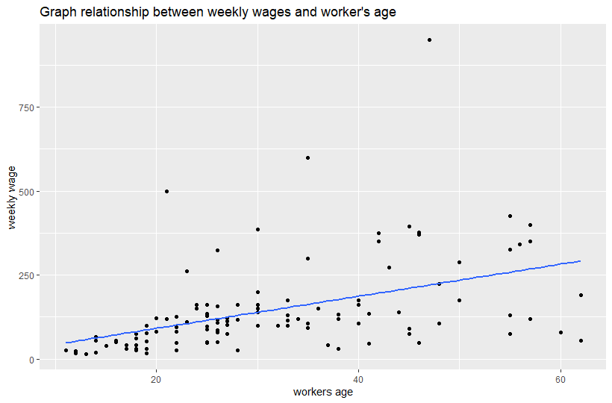

From the graph, the highest-paid worker earns around 1000 rupees and is in the late forties. The lowest earner is about 13 years and earns approximately 12 rupees. Most of the workers are between 10 to 30 years. The oldest worker is around 62 years old, and the youngest is around 11 years old. The three highest wages are between 20 to 50 years old workers. Also, majority of the workers receive 125 rupees or less. The lowest wage bracket is between workers aged 10 to 20 years.

**Question 5**

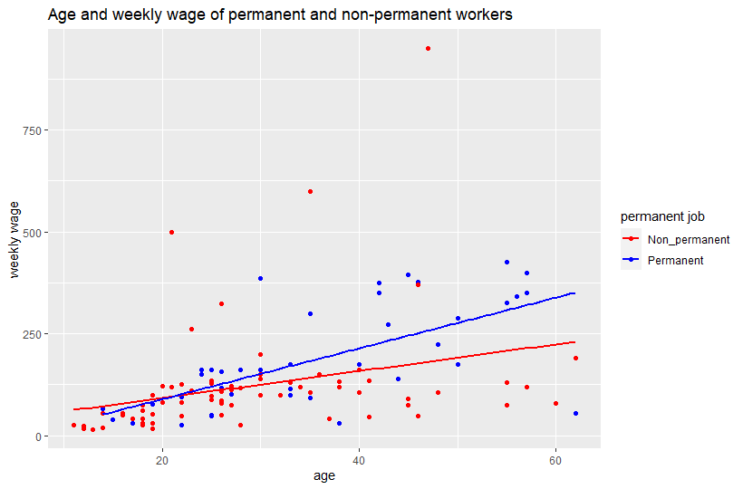

**Question 6**

|  |  |
| --- | --- |
| Regression Line | Coefficient |
| All variables with age | 3.9872 |
| Age only | 4.7755 |

The fitted regression line for Indian wages model (Y) with age (x) only is,

Y = -4.1467 + 4.775X

A unit change in age increases weekly wages by 4.78 rupees. And when the other independent variables are added to the regression model, a unit change in age increases weekly wage by 3.99 rupees. This increase is when the other variables in the model are held constant. The inclusion of other independent variables reduces age prediction in the weekly wage model. Also, the other variables have less effect on age. The inclusion of all the independent variables reduces the age coefficient by 0.79. The change in age coefficient is small and insignificant to cause a major effect in the weekly wage model.

**Part Two**

**Question 1**

Table of experimental prediction based on treatment and pretest

|  |  |
| --- | --- |
| Regression line | Coefficients |
| Intercept | 61.55790 |
| Group treatment | 4.73390 |
| pretest | 0.46002 |

The fitted model for the experiment is;

Y = 61.56 + 4.73x + 0.46z

Where y is the model prediction for the experiment, x is the treatment variable, and z is the pretest variable.

When a child receives treatment, their score increases by 4.73, and a child that had a pretest has their score increased by 0.46. The coefficient of the treatment variable is 4.73, and this means exposure to the children’s program improves their test score by 4.73 than those who did not receive any treatment. This is a significant effect on predicting the score of the children. Children who had pretest had their posttest increase by 0.46, but this is not a substantial increase in their posttest score.

**Question 2**

Interaction model of pretest and grade

|  |  |
| --- | --- |
| Fitted line | Coefficient |
| Intercept | 56.25984 |
| Treatment | 8.38 |
| Grade 2 | -19.8 |
| Grade 3 | -26.9 |
| Grade 4 | -29.5 |
| Pretest | 0.80202 |
| Group treatment: grade 2 | -4.17864 |
| Group treatment: grade 3 | -6.19673 |
| Group treatment: grade 4 | -7.12257 |

**Question 3**

The treatment effect on a child’s test score is 8.38. So, a child in grade 1 posttest score increased by 8.38.

Computing the interaction effect of the treatment score for the various grades;

The test score in grade 2 is reduced to 4.2 (8.38 – 4.18). After interaction with the treatment, a child in grade 3 the test score reduced test score to 2.18 (8.38 – 6.20). For a grade 4 child, the interaction effect decreases a child’s score to 1.26 (8.38 – 7.12).

**Question 4**

Conclusively, the interaction of a child's grade and treatment led to decreased test scores. The decrease in test scores rises with the child's grade. Hence, the children's educational program reduces the improvement level on children's scores. Also, the results could be interpreted as the children in the upper grades did not take the program seriously.